**O‘ZBEKISTON RESPUBLIKASI RAQAMLI TEXNOLOGIYALAR VAZIRLIGI MUHAMMAD AL-XORAZMIY NOMIDAGI**

**TOSHKENT AXBOROT TEXNOLOGIYALARI UNIVERSITETI**

Kompyuter injiniringi fakulteti

Sun’iy intellekt kafedrasi

**Signallar va tizimlar** fanidan

**1-TOPSHIRIQ**

**Mavzu:** 1-3 amaliy mashg‘ulotlar yuzasidan svyortka va korrelyatsiya jarayonlarini o‘rganish

Bajardi: _SAS003-2 (811-21)_ guruh talabasi

__Solijonov Asadbek_

Tekshirdi: Umidjon Xasanov

Baho:_____

TOSHKENT 2023

1. 1 o‘lchamli 2 ta signal, hamda 2 o‘lchamli 2 ta signallarni bir qadam asosida svyortka qilish.
2. Bir o‘lchamli signallar svyortkasi dasturini ishlab chiqish (ixtiyoriy dasturlash tilida)
3. 2 ta ixtiyoriy signal uchun korrelyatsiya koeffisentini hisoblang.
4. Korrelyatsiya dasturini ishlab chiqish (ixtiyoriy dasturlash tilida)

I-topshiriq

1-savol

**Teskari**

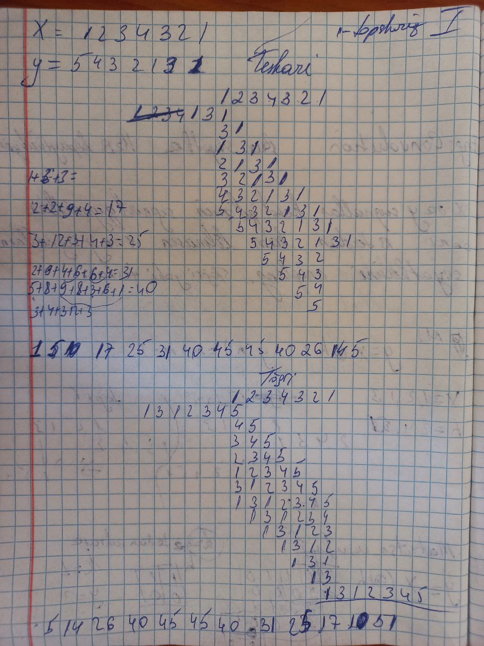

2-savol

vec1 = [1,2,3,4,3,2,1]

vec2 = [1,3,1,2,3,4,5]

const convolve = (vec1, vec2) => {

  if (vec1.length === 0 || vec2.length === 0) {

    throw new Error("Vectors can not be empty!");

  }

  const volume = vec1;

  const kernel = vec2;

  let displacement = 0;

  const convVec = [];

  for (let i = 0; i < volume.length; i++) {

    for (let j = 0; j < kernel.length; j++) {

      if (displacement + j !== convVec.length) {

        convVec[displacement + j] =

          convVec[displacement + j] + volume[i] * kernel[j];

      } else {

        convVec.push(volume[i] * kernel[j]);

      }

    }

    displacement++;

  }

  return convVec;

};

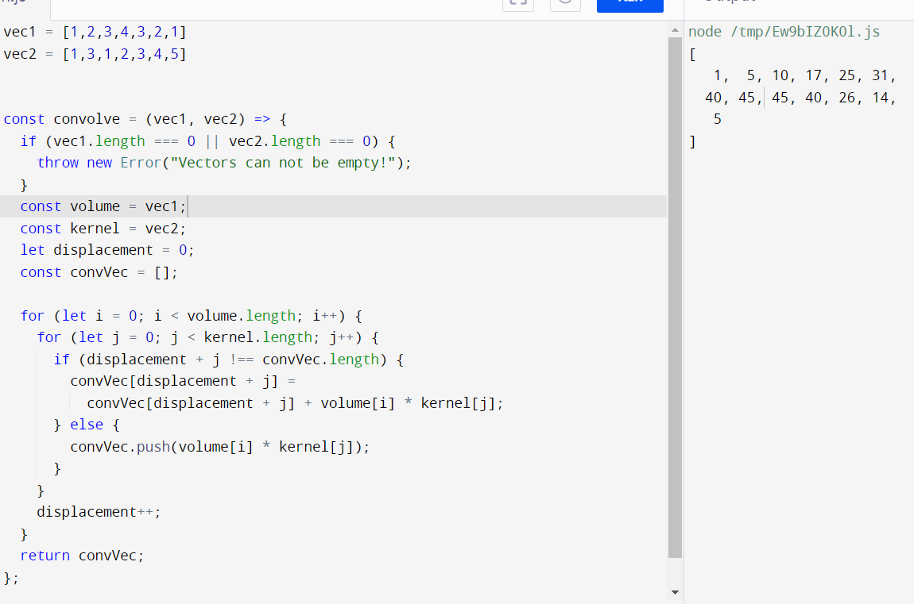

**To’g’ri**

vec1 = [1,2,3,4,3,2,1]

vec2 = [5,4,3,2,1,3,1]

const convolve = (vec1, vec2) => {

  if (vec1.length === 0 || vec2.length === 0) {

    throw new Error("Vectors can not be empty!");

  }

  const volume = vec1;

  const kernel = vec2;

  let displacement = 0;

  const convVec = [];

  for (let i = 0; i < volume.length; i++) {

    for (let j = 0; j < kernel.length; j++) {

      if (displacement + j !== convVec.length) {

        convVec[displacement + j] =

          convVec[displacement + j] + volume[i] * kernel[j];

      } else {

        convVec.push(volume[i] * kernel[j]);

      }

    }

    displacement++;

  }

  return convVec;

};

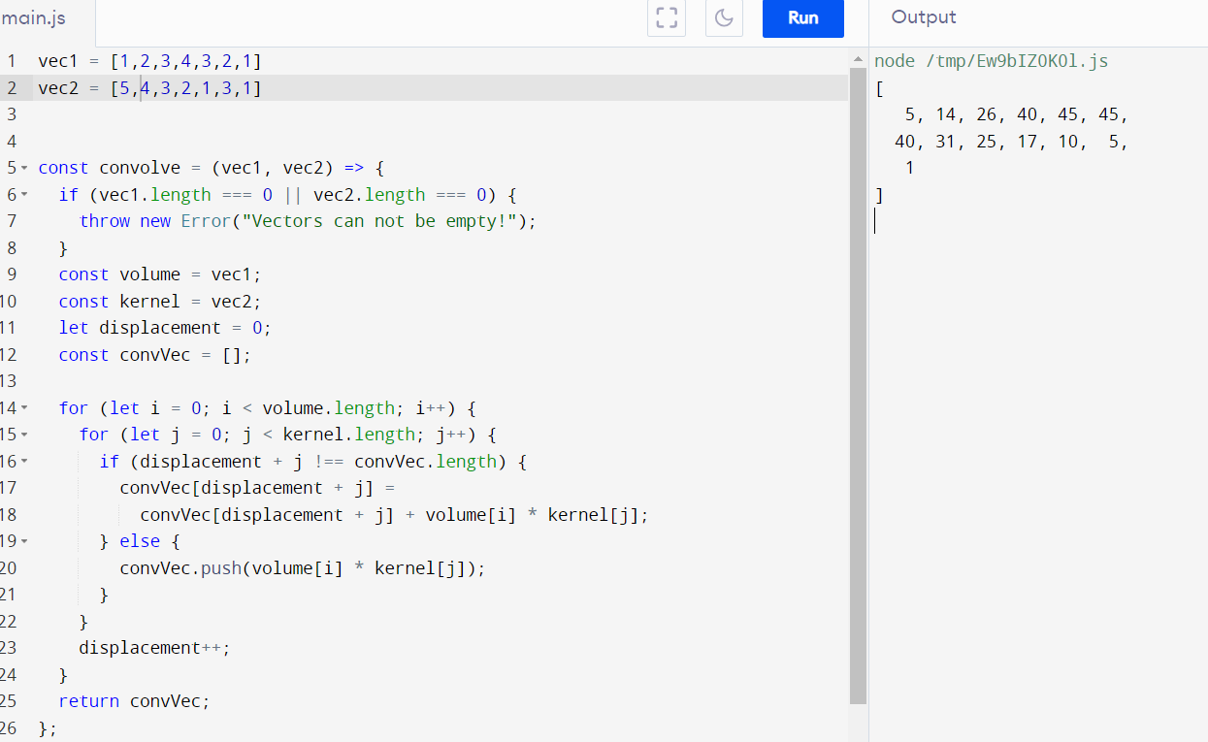

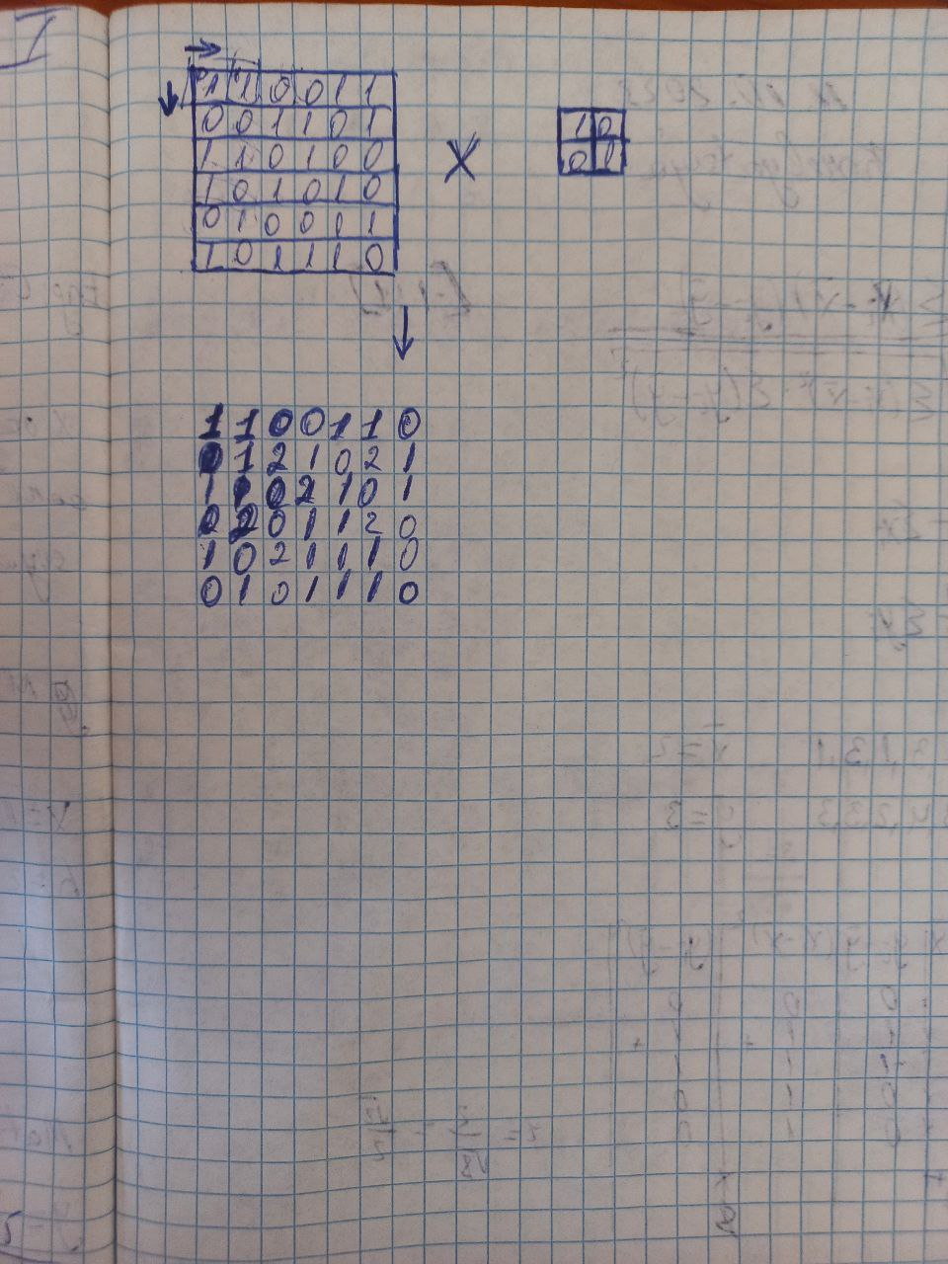

II-topshiriq.

1-savol

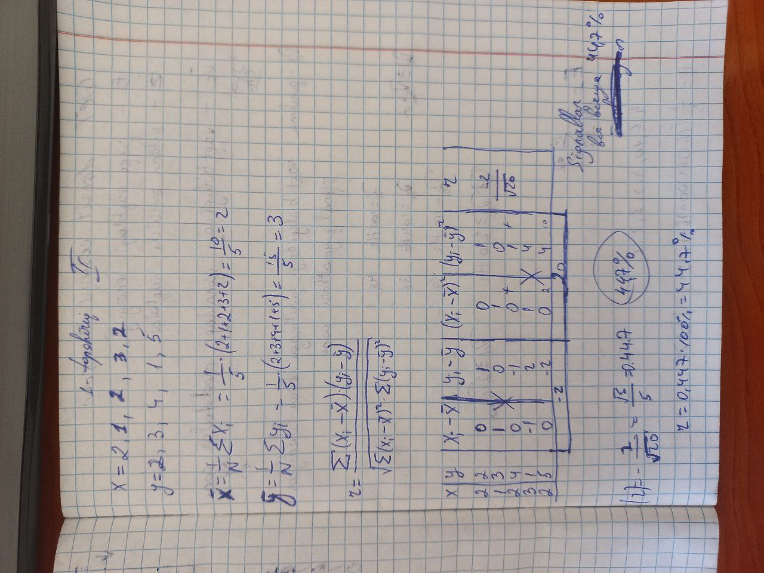

2-savol

const corr = (x, y) => {

    let sumX = 0,

      sumY = 0,

      sumXY = 0,

      sumX2 = 0,

      sumY2 = 0;

    const minLength = x.length = y.length = Math.min(x.length, y.length),

      reduce = (xi, idx) => {

        const yi = y[idx];

        sumX += xi;

        sumY += yi;

        sumXY += xi * yi;

        sumX2 += xi * xi;

        sumY2 += yi * yi;

      }

    x.forEach(reduce);

    return (minLength * sumXY - sumX * sumY) / Math.sqrt((minLength * sumX2 - sumX * sumX) * (minLength * sumY2 - sumY * sumY));

  };

  let arrX = [2,1,2,3,2];

  let arrY = [2,3,4,1,5];

  let R = corr(arrX, arrY);

  let r = (-R)*100 ;

  console.log('arrX :', arrX, ',  arrY :', arrY  ); console.log('R = ', R );

  console.log('r = ' ,r);

